**The history of Hungarian chainsaws**

***Discussion starter***

I intend this article as a keynote, because we have very little information about the chainsaws that were once produced in Hungary, and I trust that someone will be able to add new information, possibly new types, to the knowledge we have now.

A few weeks ago, i.e. before August 2019, even I only knew about one Hungarian chainsaw, the KL 150/1 type manufactured by Kismotor és Gépgyár, which is also in the collection of János Bojtos, and of which pictures were taken on this website and on Facebook I also shared it as the only Hungarian chainsaw type.

Several comments were received on my Facebook post, according to which this type is not the only Hungarian chainsaw, but that it also had predecessors.

We currently know of four versions, thanks to Tibor Cziéber, Antal Néth, József Tóth, who provided me with photographs and newspaper articles, and last but not least to János Bojtos, without whom this process could not have started.

There is a lot of uncertainty on the subject, since these machines were made to order from the national defense, so not only their technical parameters, but even their existence was classified as a military secret.

I would also like to ask anyone who has any information, documents or photos to contact us, but also those whose family members include soldiers, travelers, machine manufacturers, archivists, who may have insight into the chainsaw between the beginning of the Second World War and the mid-1950s for production, ask if you have any knowledge on the subject, so that we can map the history of Hungarian chainsaw production as accurately as possible.

***What we know so far***

From the conversations and correspondence with the above-mentioned gentlemen, as well as from the pictures and newspaper articles, we can identify four types of machines, three of which were found. The KL 150/I type can be found in the largest number of copies in various collections.

According to our current knowledge, the designs of the first Hungarian chainsaw were patented by János Csonka in 1935.

János Csonka designed two machines, one of which was driven by a gasoline engine placed on a small car through a flexible shaft, and the other was directly driven by an electric motor.

Both were actually produced and handed over to the national defense for testing.

Unfortunately, during the Second World War, these machines disappeared and were destroyed, only a copy of the electric drive was found, which was in the possession of Tibor Cziéber for a while, and is currently the brightest Hungarian jewel in the collection of József Tóth.

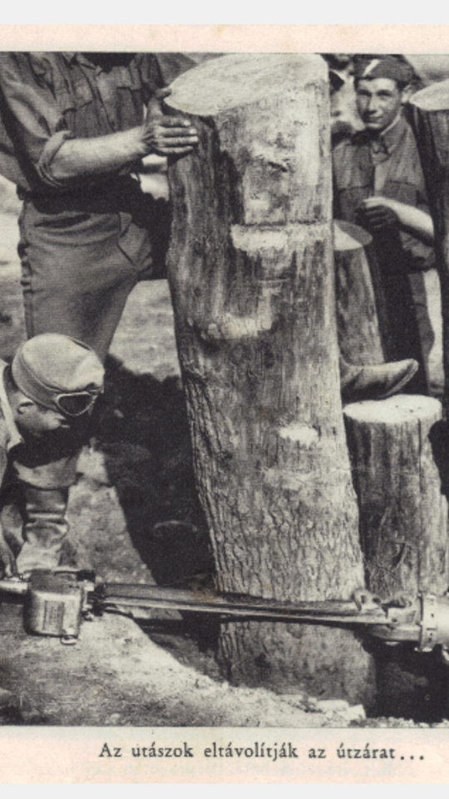*János Csonka's electric chainsaw*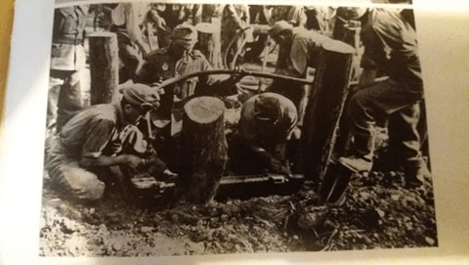János Csonka's gas-powered chainsaw with flexible drive in contemporary footage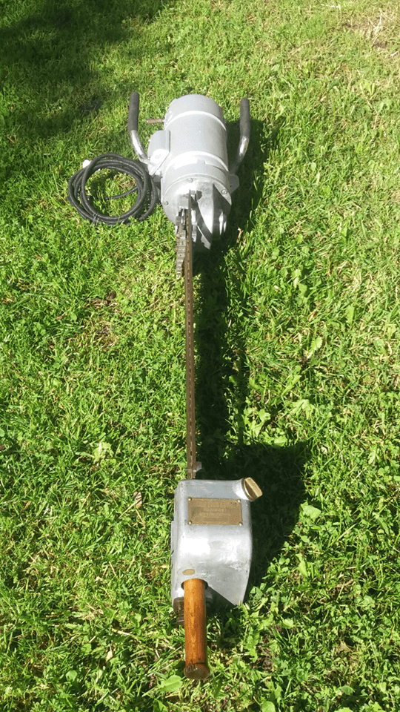The only known copy of János Csonka's electric chainsaw from the collection of József Tóth. Photo: Tibor Cziéber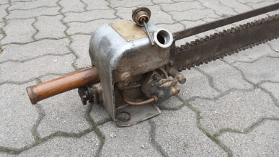Oiling mechanism *of János Csonka's electric chainsaw*  
*Photo: Tibor Cziéber*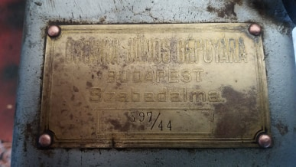János Csonka 's *electric chainsaw*  
*Photo: Tibor Cziéber*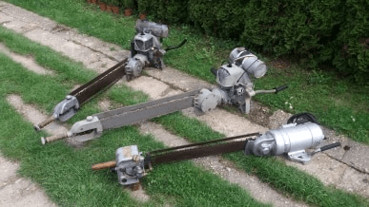Three saws  
*Photo: Tibor Cziéber*

In the pictures below, which were made available to me by Tibor Cziéber, you can see the machines made in the machine factory of János Csonka. The only remaining electric machine has the year of manufacture 1944.

After János Csonka, his son Béla Csonka, also a mechanical engineer, left his mark on the table of Hungarian chain saw production.

István Doros, the former director of the Forestry Museum in Szilvásvárad, revealed in a newspaper article that the National Guard ordered the production of a chainsaw from the Budapest *Kismotor és Gépgyártó* for its technical (travel) work in the early 1950s, but according to other documents and publications that have come to light since then, it is likely that in fact the order may have been made earlier, because in the anniversary publication of Kismotor és Gépgyár, the year 1950 is listed next to the KL 150/I type.

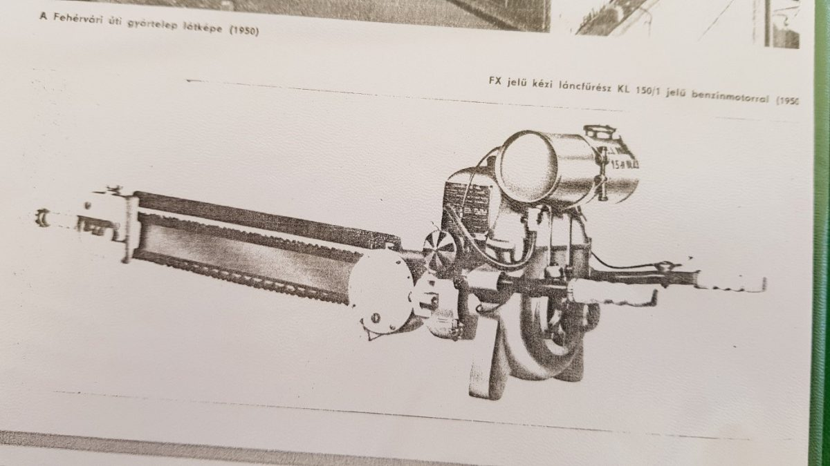Jubilee publication of Kismotor és Gépgyár

The fact is that the mechanical engineer Béla Csonka and his team designed it, and then the factory manufactured the two-person chainsaw based on it, according to the available data, only *ten copies were made* .

We also do not know whether the ten copies mentioned by István Doros refer to the prototype or to the KL 150/I type also found in the Szilvásvárad museum.

It can definitely be stated that two types were made, they are definitely different in appearance, but we do not know that the technical content has changed. One of these could have been the military version, the other - according to my assumption - might have been given to the foresters, for civilian use.

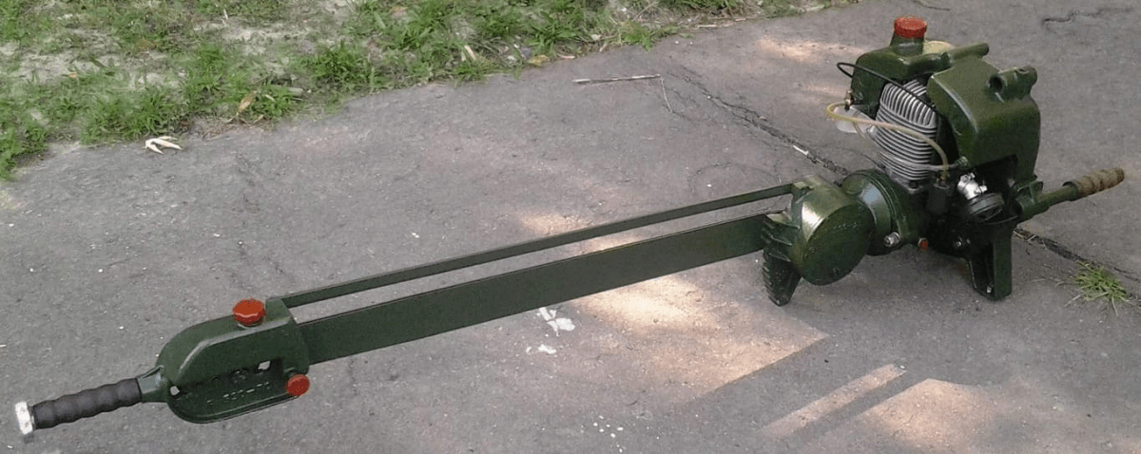The military version after restoration from the collection of Antal Néth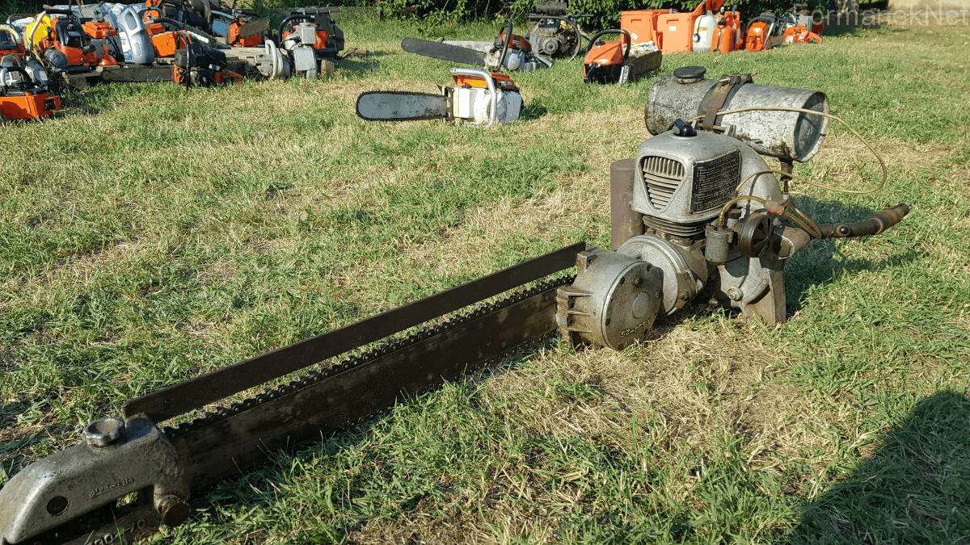KL 150/I from the collection of János Bojtos

István Doros's article also reveals that the machine was treated as a war secret, so it could not get into the hands of a real professional, that is, a forestry worker who harvests wood. This meant that *the machine's faults were not discovered and corrected at that time* .

Later, two expert opinions on the defects of the KL 150/I were prepared, namely on April 27, 1956 and May 14, 1956. This is evidenced by the records that can still be found in the Szilvásvárad museum. On behalf of the National Directorate General of Forestry, experts independently tested the KL-150/I type marked machine at the Bajai State Forest Farm in Pörbölyi and the Börzsönyi State Forest Farm in Nógrádverőce. (Unfortunately, during my visit in August 2019, the staff at the museum did not know about the minutes and, according to their statement, they did not come across such a document during the inventory carried out shortly before.)

According to Doros:

*"The expert opinions - to put it mildly - are not favorable* .

In favor of the machine, compared to the then more widely used Czechoslovak-made, MRP gasoline engine chainsaw machine, almost only one good feature is mentioned, the lighter weight.

Without pretending to be complete, I will mention some of its shortcomings:

* Holding the chainsaw is uncomfortable, the distance between the two handle horns is small, and the horns are short.
* The guide plate is narrow and weak and difficult to turn.
* In the oiling mechanism, the guide wheel is not covered, which is why it is dangerous.
* The engine is difficult to start, and cannot be started when it is warm, after thirty minutes of operation, although the machine is not yet warm, it still stops by itself.
* The engine cannot handle the load.

In summary, both protocols mention that the introduction of the chainsaw in practice would mean a step back compared to the already proven MRP type chainsaws."

István Doros - who probably did not know about the chainsaws designed and manufactured by János Csonka - concludes his article with the following:

"On the other hand - if you like, also as a kind of summary - we would rather highlight the following: *we are proud of this chainsaw that deserves a better fate, and of the professional team that created it* . It is not their fault that his destiny could not be fulfilled and that he could not serve Hungarian forestry. Then we could say that wood was produced by Hungarian chainsaws in Hungarian forests."

I would only add to the above that we are proud of all Hungarian chainsaws and I trust that at least one copy of the missing type will be found.

Some pictures of the details of the machine. Photo: Antal Néth

Formulärets överkant

[[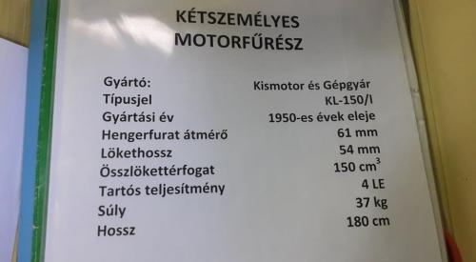](https://formaneknet-hu.translate.goog/wp-content/uploads/photo-gallery/MLF_ADATOK.jpg?bwg=1576190317&_x_tr_sl=auto&_x_tr_tl=en&_x_tr_hl=sv&_x_tr_pto=wapp)](https://formaneknet-hu.translate.goog/wp-content/uploads/photo-gallery/MLF_ADATOK.jpg?bwg=1576190317&_x_tr_sl=auto&_x_tr_tl=en&_x_tr_hl=sv&_x_tr_pto=wapp)

[[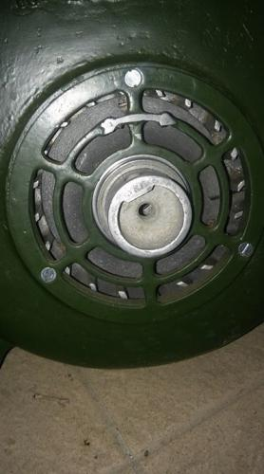](https://formaneknet-hu.translate.goog/wp-content/uploads/photo-gallery/MLF_Ber%C3%A1nt%C3%B3.jpg?bwg=1576190317&_x_tr_sl=auto&_x_tr_tl=en&_x_tr_hl=sv&_x_tr_pto=wapp)](https://formaneknet-hu.translate.goog/wp-content/uploads/photo-gallery/MLF_Ber%C3%A1nt%C3%B3.jpg?bwg=1576190317&_x_tr_sl=auto&_x_tr_tl=en&_x_tr_hl=sv&_x_tr_pto=wapp)

[[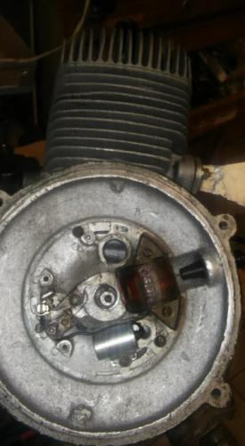](https://formaneknet-hu.translate.goog/wp-content/uploads/photo-gallery/MLF_Gy%C3%BAjt%C3%A1s.jpg?bwg=1576190317&_x_tr_sl=auto&_x_tr_tl=en&_x_tr_hl=sv&_x_tr_pto=wapp)](https://formaneknet-hu.translate.goog/wp-content/uploads/photo-gallery/MLF_Gy%C3%BAjt%C3%A1s.jpg?bwg=1576190317&_x_tr_sl=auto&_x_tr_tl=en&_x_tr_hl=sv&_x_tr_pto=wapp)

[[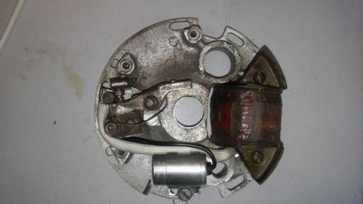](https://formaneknet-hu.translate.goog/wp-content/uploads/photo-gallery/MLF_Gy%C3%BAjt%C3%A1s2.jpg?bwg=1576190317&_x_tr_sl=auto&_x_tr_tl=en&_x_tr_hl=sv&_x_tr_pto=wapp)](https://formaneknet-hu.translate.goog/wp-content/uploads/photo-gallery/MLF_Gy%C3%BAjt%C3%A1s2.jpg?bwg=1576190317&_x_tr_sl=auto&_x_tr_tl=en&_x_tr_hl=sv&_x_tr_pto=wapp)

[[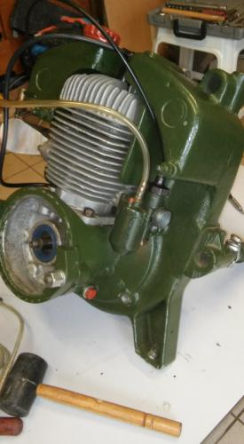](https://formaneknet-hu.translate.goog/wp-content/uploads/photo-gallery/MLF_RK.jpg?bwg=1576190317&_x_tr_sl=auto&_x_tr_tl=en&_x_tr_hl=sv&_x_tr_pto=wapp)](https://formaneknet-hu.translate.goog/wp-content/uploads/photo-gallery/MLF_RK.jpg?bwg=1576190317&_x_tr_sl=auto&_x_tr_tl=en&_x_tr_hl=sv&_x_tr_pto=wapp)

[[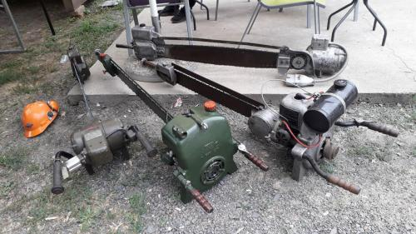](https://formaneknet-hu.translate.goog/wp-content/uploads/photo-gallery/Nemzeetk%C3%B6zi.jpg?bwg=1576190317&_x_tr_sl=auto&_x_tr_tl=en&_x_tr_hl=sv&_x_tr_pto=wapp)](https://formaneknet-hu.translate.goog/wp-content/uploads/photo-gallery/Nemzeetk%C3%B6zi.jpg?bwg=1576190317&_x_tr_sl=auto&_x_tr_tl=en&_x_tr_hl=sv&_x_tr_pto=wapp)

Finally, by clicking on the link below, you will jump to the page of the KL-150/1 machine, where you can see more pictures, data and even a video about this type.

https://formaneknet-hu.translate.goog/muzeum-k-z/kismotor-es-gepgyar-tipus/kismotor-es-gepgyar-kl-150-1/?_x_tr_sl=auto&_x_tr_tl=en&_x_tr_hl=sv&_x_tr_pto=wapp