A friend of mine has had some bikes stolen that are very rare. He need help locating them.
Any help and info about this is appersiated.

Bianchi 1936
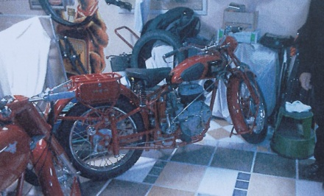

Dunelt 500

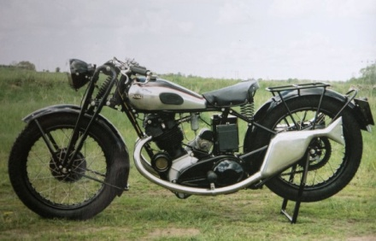
Triumph Sport 1930

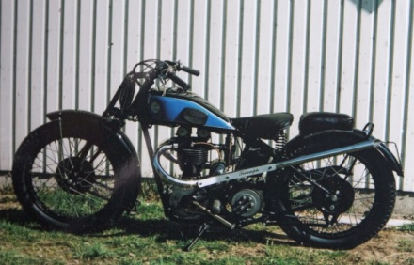

AJS 500 1930
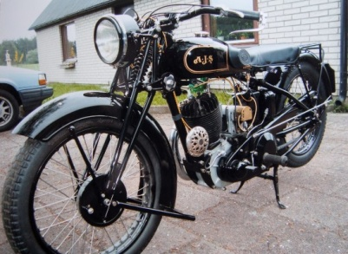
Viktoria Avanti 1957, av samma årsmodell. Tjuvarna fick också med sig en klassisk moped i form av en Viktoria Avanti -1957

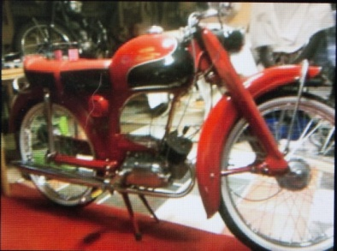.

http://www.nsk.se/2015/06/20/hans-karaste-agodelar-stals/
http://www.kristianstadsbladet.se/kristianstad/veteraner-stulna-under-nattlig-kupp/

